**Power Management**

* **Modes:**
* **Run mode: Every components should work except data transfer protocols (USB) until it connected to the system.**
* **Different cases:**

1. **It can be connected to the power bank or any device, in that case take the charge from the device for running and charging the battery.**
2. **If the device is not giving required power for all, limit the job only to charging.**



* **IDLE mode: In this case every components are working expect the GPU and VPU unit. System is waiting for a job to do.**
* **The photo review and video playback can be done in this mode.**

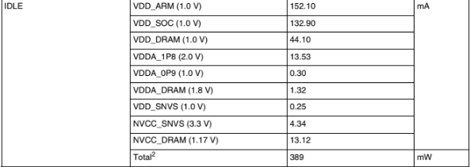

* **Deep Sleep Mode: It is the most power saving mode. Add a additional feature called sleep mode for the customers, so that they donot want to switch off and on every time.**

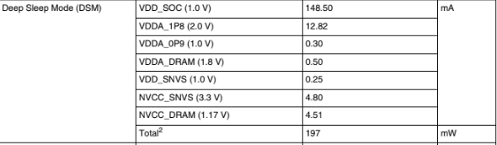

* **Off mode: All the components are in off state.**

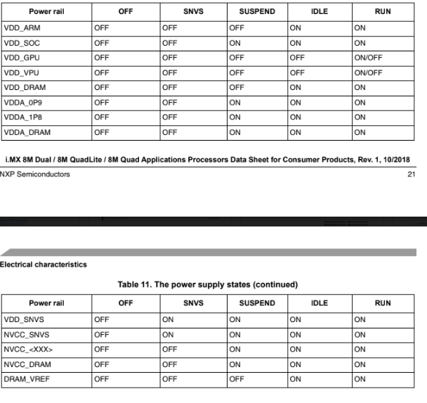

**Power supplies conditions and restrictions**

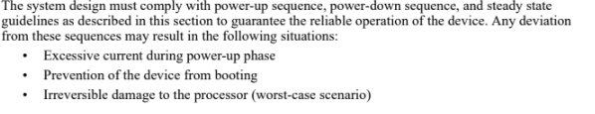

* **Power Up sequence**





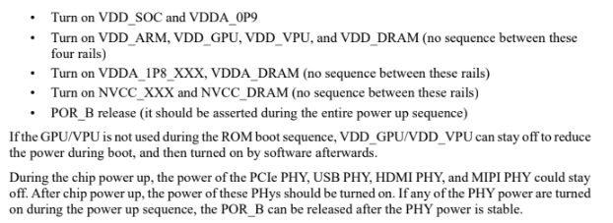

* **Power Down Sequence**



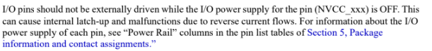

* **Power Ranges**

